**Template:**

<https://github.com/zhellDarwin/kubewithisitio/tree/master/istio%20api>

**Prerequisite:**

1. Need to have aks(azure kubernetes service)
2. Istio installed
3. Template mentioned above

**Steps:**

1.Install the demo profile

* istioctl install --set profile=demo -y
* istioctl verify-install

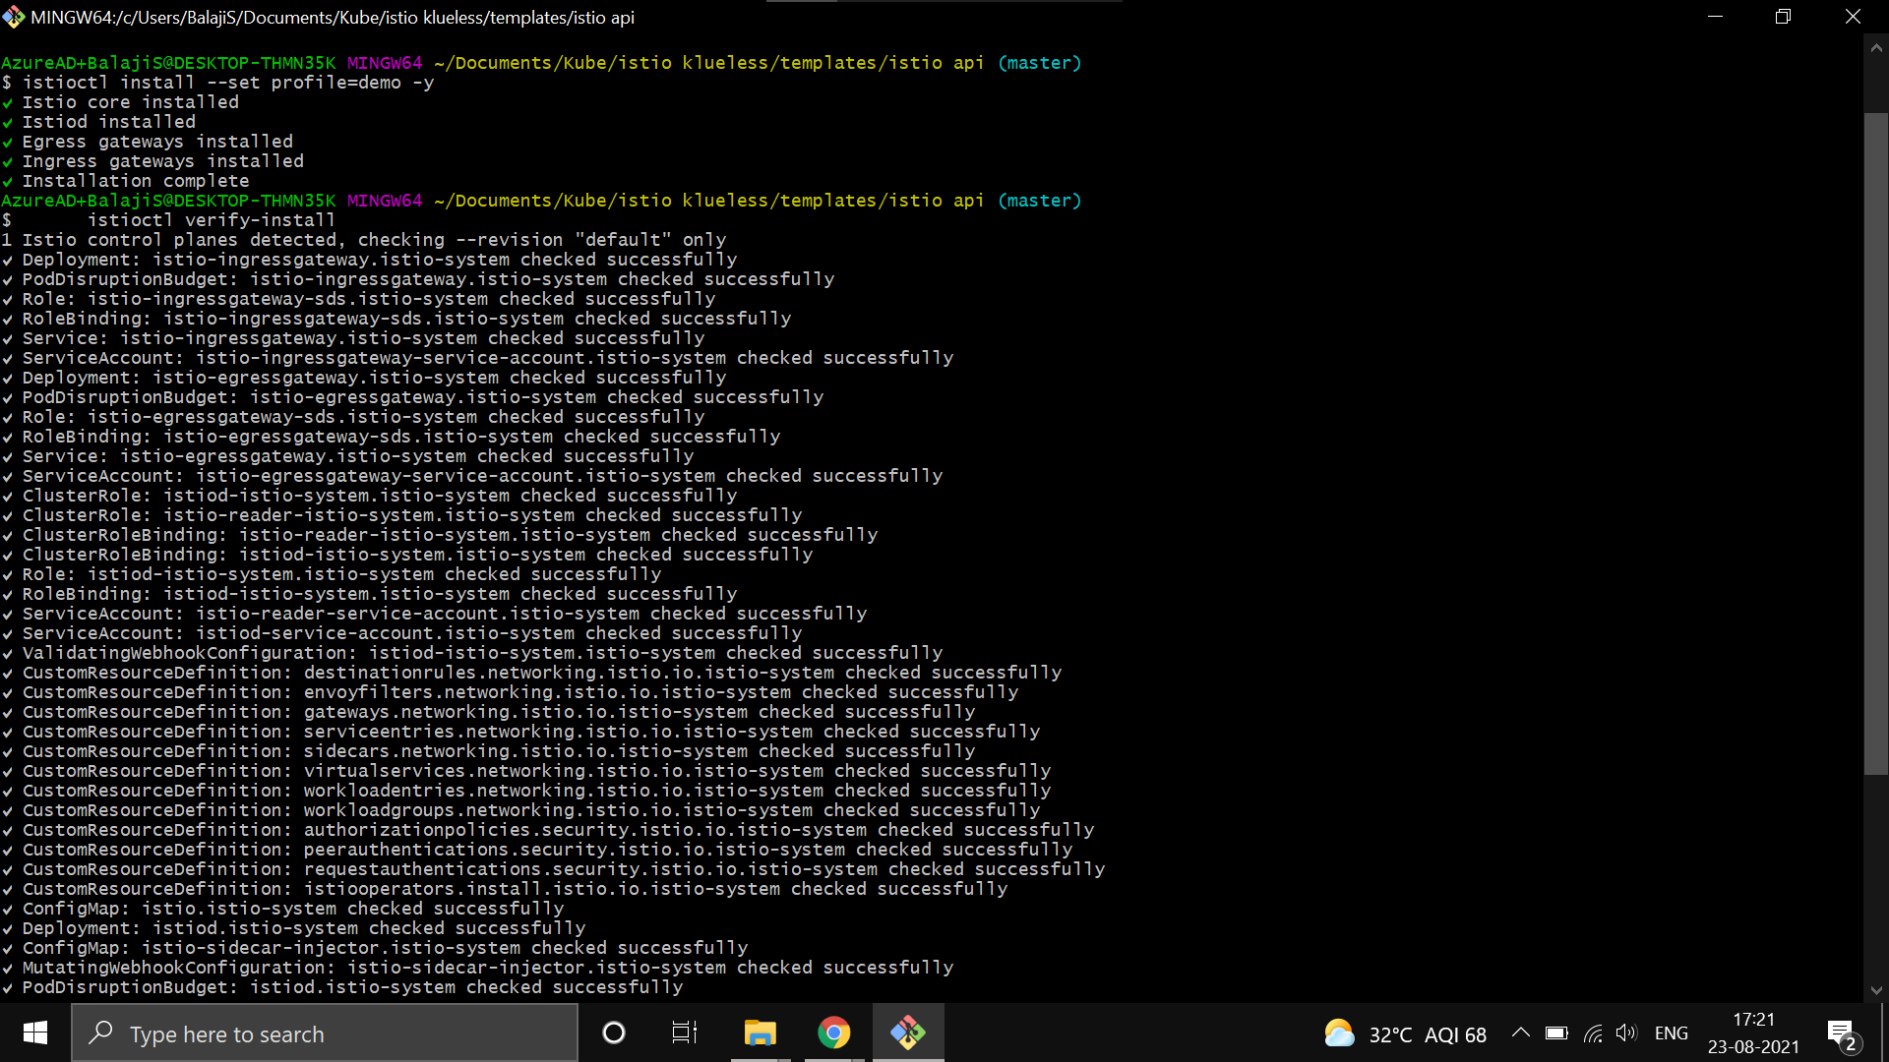

2. Create a namespace

# Create namespace

* kubectl create ns istiodemo

# Set the namespace

* kubectl config set-context --current --namespace=istiodemo

3.Add label to the target namespace to enable automatic side-car injection

* kubectl label namespace istiodemo istio-injection=enabled
* kubectl get ns istiodemo --show-labels

4.Deploy the application

* kubectl apply -f shopapi.yaml -n istiodemo
* kubectl apply -f ingress.yaml -n istiodemo

5.Getting Ingress IP & Port

* kubectl get svc istio-ingressgateway -n istio-system

**Reference:**

<https://github.com/ilyas-it83/globalazure2021/blob/main/istio.md>